

Club Visits

Location of Material: https://www.toastmasters.org/leadership-central/district-leader-tools/training/division-and-area-directors-training-materials

5/05/2021

Club Visits
Introduction
The purpose of this session is to assist Area Directors in developing strategies to, through club visits, support and motivate clubs in providing the best possible member experience, enhancing member retention, and building membership.
Overview
First, Area Directors will discuss the elements of a successful club visit. Then, they present their key ideas to the rest of the participants. Finally, they will brainstorm how they can identify success and prepare to support clubs.
In this session, facilitators discuss the following topics:
- What is a Successful Club Visit?
- Club Visit Outcomes
Objectives
After completing this session, Area Directors will be able to do the following:
- Identify what a successful club visit looks like
- Recognize club visit outcomes
- Develop strategies to hold productive and successful club visits
By meeting these objectives, Area Directors will support their Area in delivering the best possible member experience.
Materials
- PowerPoint
- Session Workbook PDF
Time
These session materials are designed for a session that takes approximately 1 hour and 38 minutes. However, you may choose to present this topic over multiple days or in a shorter format, depending on your preference.
This guide includes suggestions about how to alter the content to suit your needs below:
- This session divides into two shorter sessions by dividing the topics into standalone sessions. The review slide in each session would become the conclusion slide, and the Pre-work and Session Workbook is adjustable to match the material.
- Check the Club Visits Session Outline for some options of how you might break this session up.

You should add at least one 5-minute break in any session that lasts longer than 60 minutes.
Session Preparation
- Familiarize yourself with the pre-work for this session, where Area Directors will:
  - Watch Dashboards for Area Directors (Video)
Members who do not have access to YouTube can watch the video by clicking this link.
    - This video will help Area Directors understand the function and features of their dashboard. Dashboards are a critical tool for preparing for club visits.

  - Watch Dashboards for Club Officers (Video)
Members who do not have access to YouTube can watch the video by clicking this link.
    - This video will help Area Directors understand what clubs see in their dashboards and gives them more information to reference.

  - Review Dashboard information for clubs in your Area
    - Area Directors will have a more impactful experience having up-to-date information on the clubs in their areas.

  - Review Area Director Club Visit Report
    - Area Directors need to be familiar with the report before attending this session.

  - Review Moments of Truth
    - Moments of Truth is a tool that clubs should be using to improve their club and member experience. Area Directors should be familiar with this tool before attending this session.

  - Review the Distinguished Club Program and Club Success Plan
    - Area Directors review Club Success Plans of the clubs in their area to understand their plans and to support their outcomes through club visits. The Distinguished Club Program lays out areas of success clubs strive to achieve. Area Directors support clubs in working through this program.

  - Complete Questions to Consider
    - These questions promote reflection on the pre-work and their experiences. These add depth to the discussion in each Breakout Room Activity and the Whole Room Discussions.
- Practice with your co-facilitator(s) to ensure smooth transitions throughout the session, if applicable.
- Consider assigning a technical assistant to help with the logistics of the session and (breakout rooms, chat, technical issues, etc.) when delivering this session online.
- Review the instructions and materials for each Breakout Room Activity
- There is a slide at the end of this session that gives five minutes for participants to fill out a survey. Consider creating a survey to gather feedback on your session or remove the slide.

Pre-Session
START the meeting 30 minutes ahead of time.
START sharing the slides.
note to facilitator
The following slide should be updated to reflect who will be handling technical support.
SHOW the Pre-Session slide.
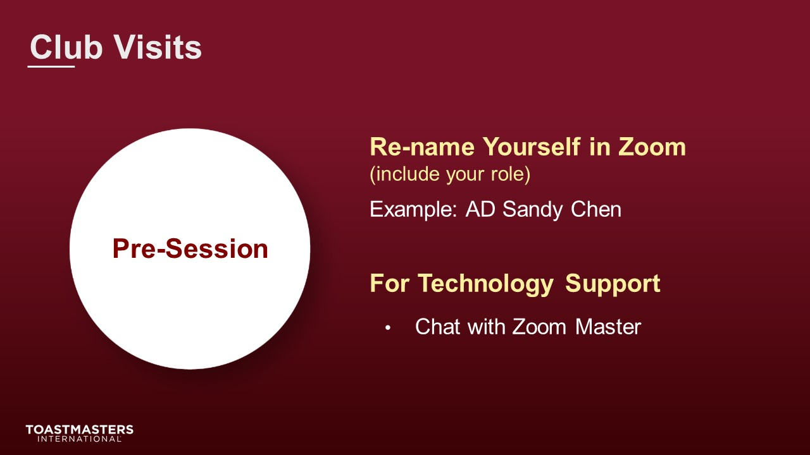
MONITOR chat messages.

Introduction
(5 minutes)
note to facilitator
Use this time to introduce yourself formally to the Area Directors. A good introduction sets the tone for the session and highlights your experience and credibility. This is an excellent time to share a story related to the topic from your background as a Toastmaster leader.
Throughout this session, it is essential to encourage them to use the pre-work insights and apply them to their current interactions.
This session intends to have Area Directors discuss how to prepare for club visits and understand what outcomes they are working towards with each visit.
The following slide should be updated to reflect where this session falls in your training program.
SHOW the Session Title slide.
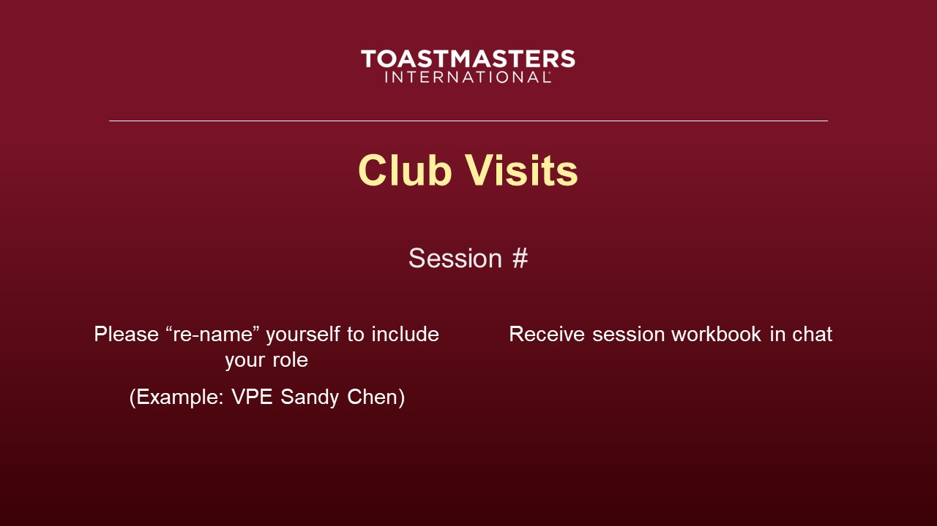
PRESENT
- [insert your talking points here]
SEND session workbook to club officers in chat.

SHOW the Agenda slide.
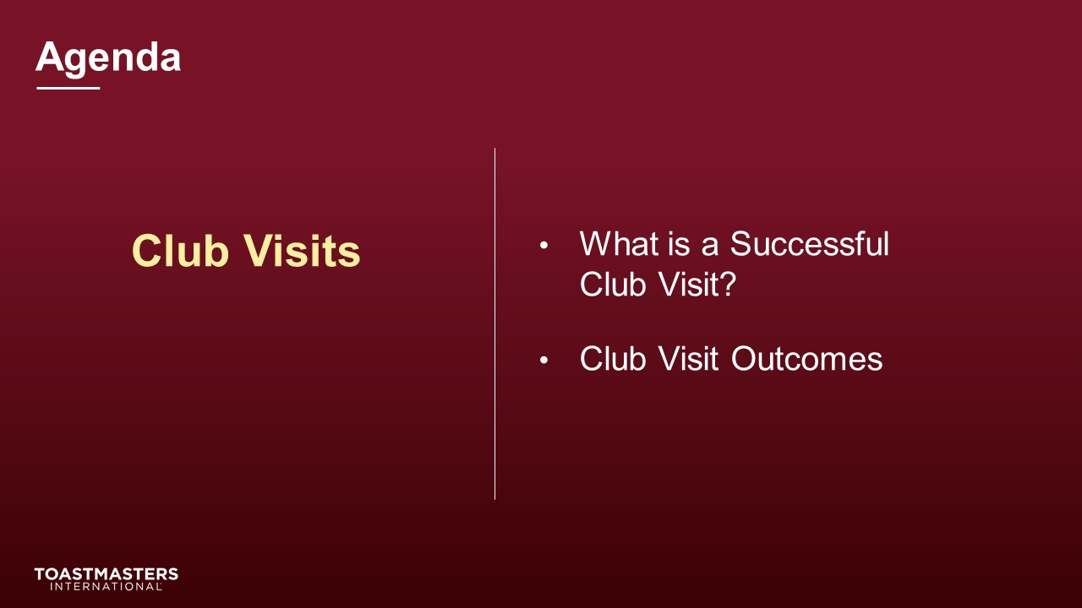
SHOW the Objectives slide.
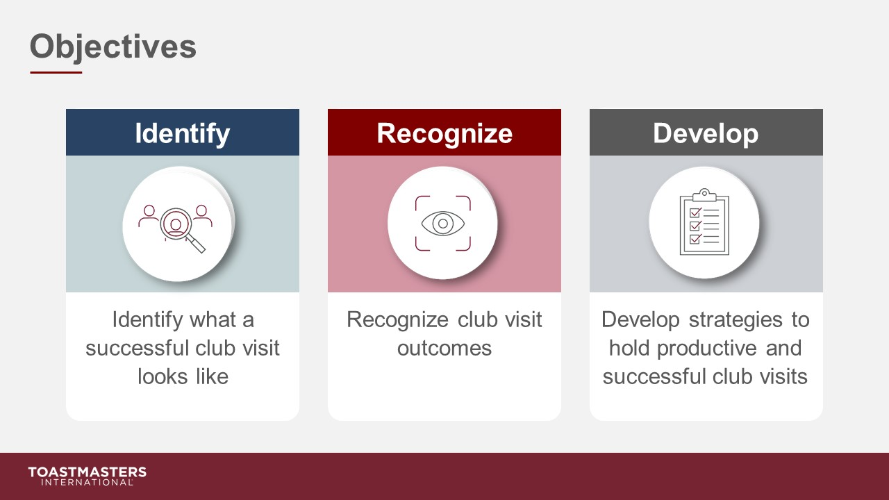

What is a Successful Club Visit?
(38 minutes)
note to facilitator
Remind participants to open their pre-work so they can refer to concepts and their responses to questions. This reminder will help guide their participation in the discussions they will have in the first section.
This section establishes the elements of a successful club visit.
PREPARE Breakout Rooms by randomly assigning a minimum of three and a maximum of four Area Directors to each room.
SHOW the Section Title slide.

PRESENT
- Club visits are your most impactful tool in supporting and influencing clubs throughout your term. In this section, we will be defining what is a successful club visit. This will assist in your club visit preparation.
- To do this, we will be using a Breakout Room Activity that will focus on making visits count.
SHOW the Breakout Room Activity slide.
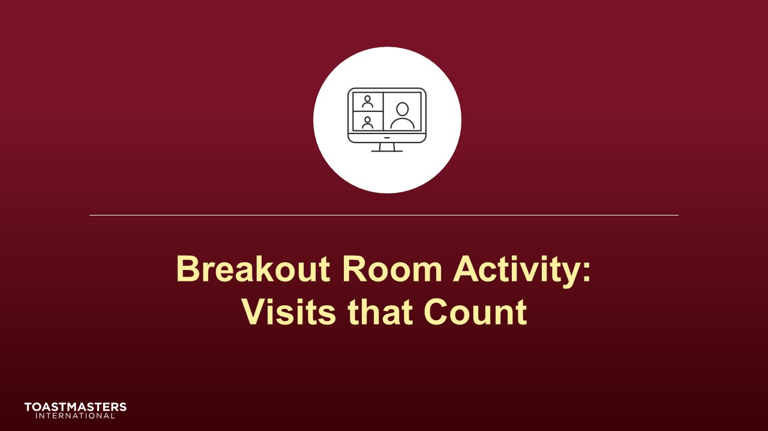
SHOW the Breakout Room Tips slide.
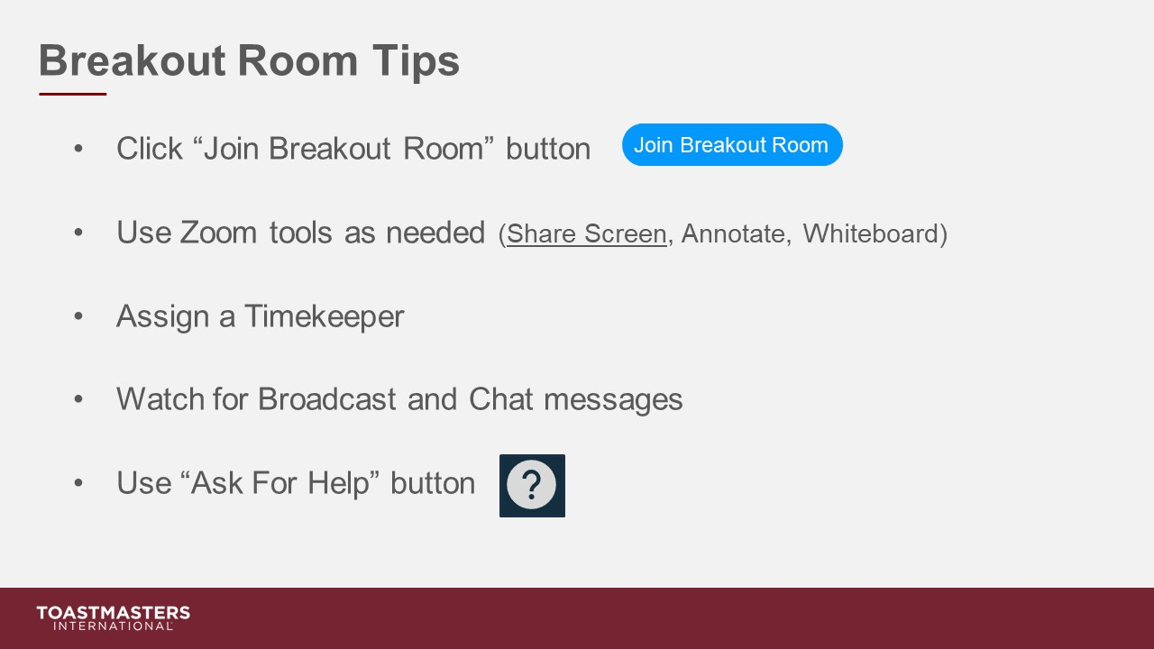
note to facilitator
The following slide's purpose is to remind Area Directors about a few of the tools available to them in virtual Breakout Rooms. You may need to adjust these according to the platform that you are using to deliver this material. Plan to spend less than one minute on the next slide.
Ideally, you would like to see a minimum of three and a maximum of four Area Directors per group for this activity. You may have to adjust the number per group based on the number of participants because you will be asking them to share highlights of their results. Adjust group sizes and speaking time for each spokesperson to keep your session within the schedule parameters.
SHOW the Instructions slide.
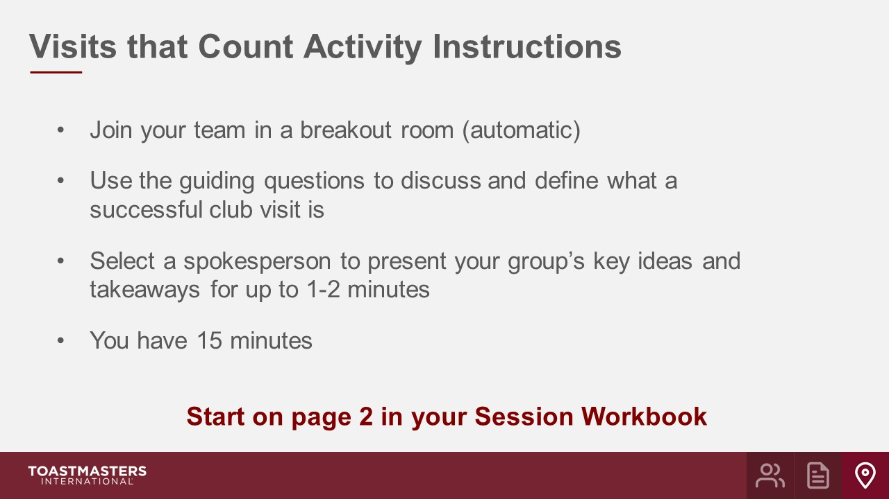
PRESENT
- We will send a two-minute warning before the end of the activity.
- I will be available to answer questions or provide assistance.
OPEN Breakout Rooms for activity (3-4 Area Directors per room).
MONITOR requests for assistance from Breakout Rooms.
VISIT Breakout Rooms to offer assistance and guidance, as needed.
SEND Broadcast after 5 minutes has elapsed: You have 10 more minutes.
SEND Broadcast after 10 minutes has elapsed: You have 5 more minutes.
SEND Broadcast after 13 minutes has elapsed: In approximately 2 minutes, you will be asked to return to the main session room.
CLOSE Breakout Rooms after 15 minutes.
SHOW the Whole Room Discussion slide.
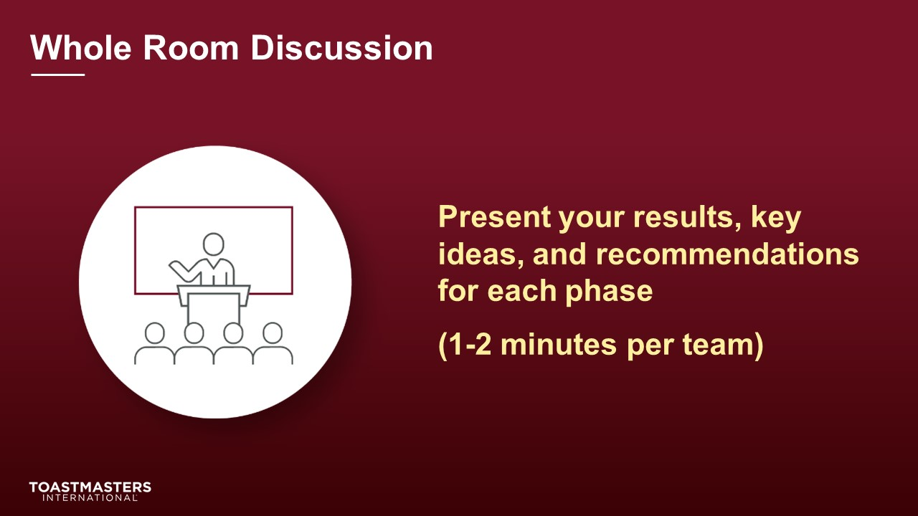
SHOW the Review slide.
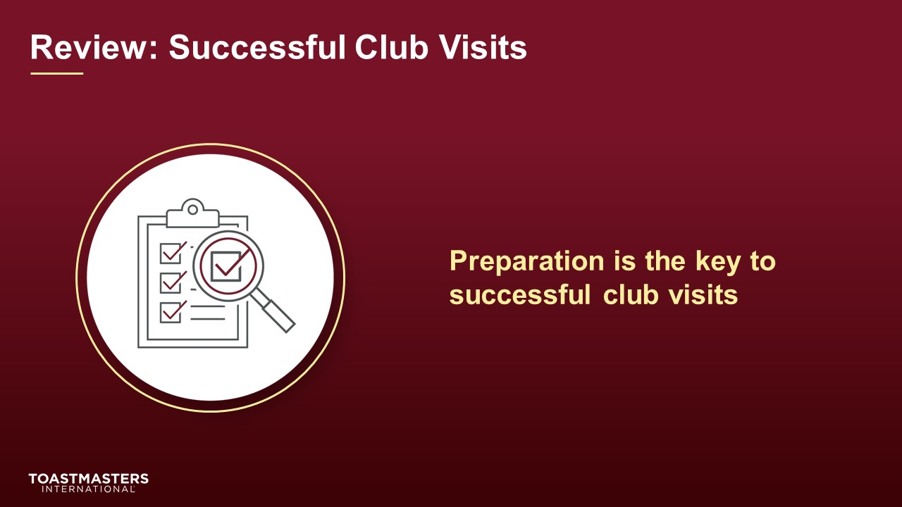

Club Visit Outcomes
(45 minutes)
note to facilitator
The purpose of this next section is to assist Area Directors in identifying club visit outcomes. The two categories of outcomes are recognition and support. They will brainstorm positive items to recognize clubs for and anticipate common issues that clubs may have. The activity leads Area Directors to recognize clubs and to identify what they can do to support clubs in need.
PREPARE Breakout Rooms by randomly assigning a minimum of three and a maximum of four Area Directors to each room.
SHOW the Section Title slide.

PRESENT
- Club visits are a crucial tool in an Area Director’s toolbox. Visits build relationships, improve club planning leading to club excellence, member retention, and club growth. These are achieved best through understanding what outcomes an Area Director may create through proper planning and preparation.
note to facilitator
The purpose of the following two slides is to identify the two categories of outcomes for a club visit. The first is recognition and the second is support. Recognition is a crucial tool to motivate clubs and recognize the success the club is experiencing. While recognizing successes, Area Directors should be looking for areas that a club could use support. After identifying these support areas, they should share guidance and resources to support growth opportunities. They will be using these two categories to guide their work in the next Breakout Room Activity.
SHOW the Present slide.
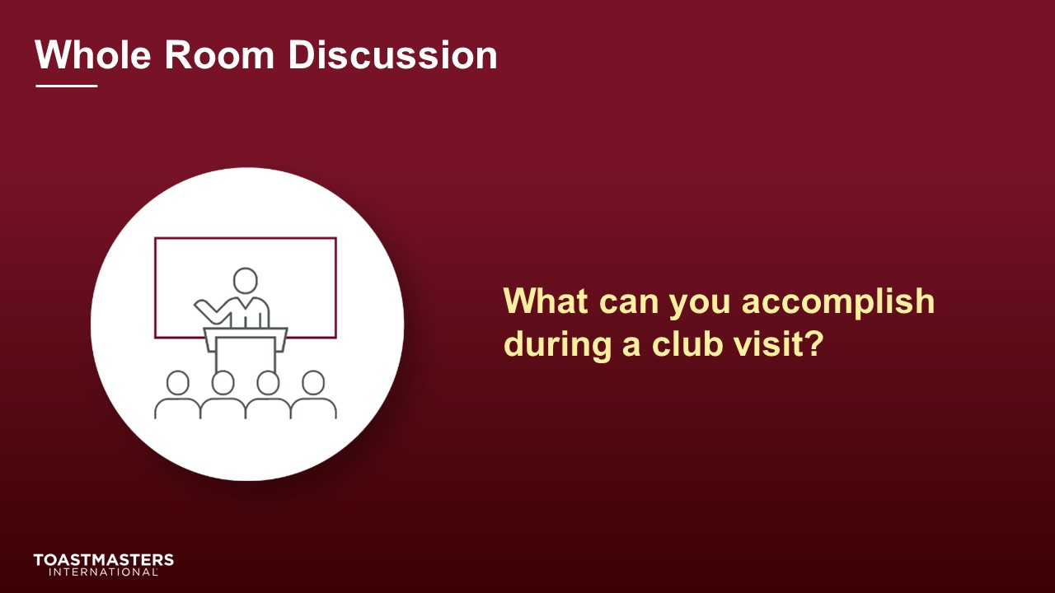
DISCUSS responses for up to two minutes.
SHOW the Breakout Room Activity slide.
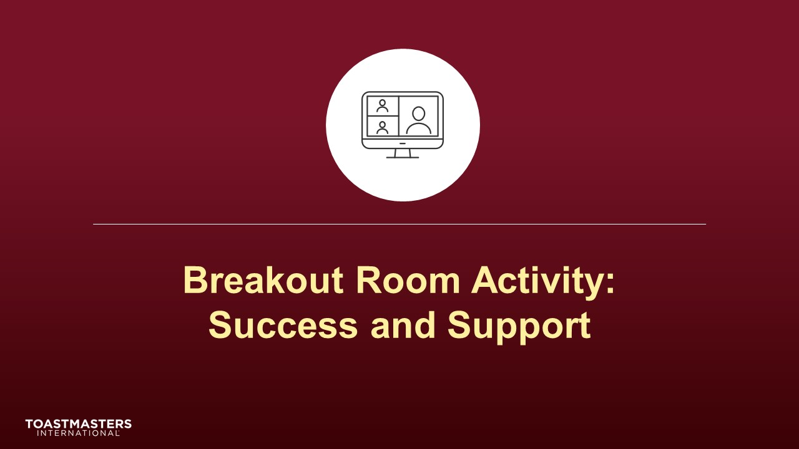
Note To Facilitator
The following slide's purpose is to remind Area Directors about a few of the tools available to them in virtual Breakout Rooms. You may need to adjust these according to the platform that you are using to deliver this material. Plan to spend less than one minute on the next slide.
Ideally, you would like to see a minimum of three and a maximum of four Area Directors per group for this activity.
SHOW the Breakout Room Tips slide.
SHOW the Instructions slide.
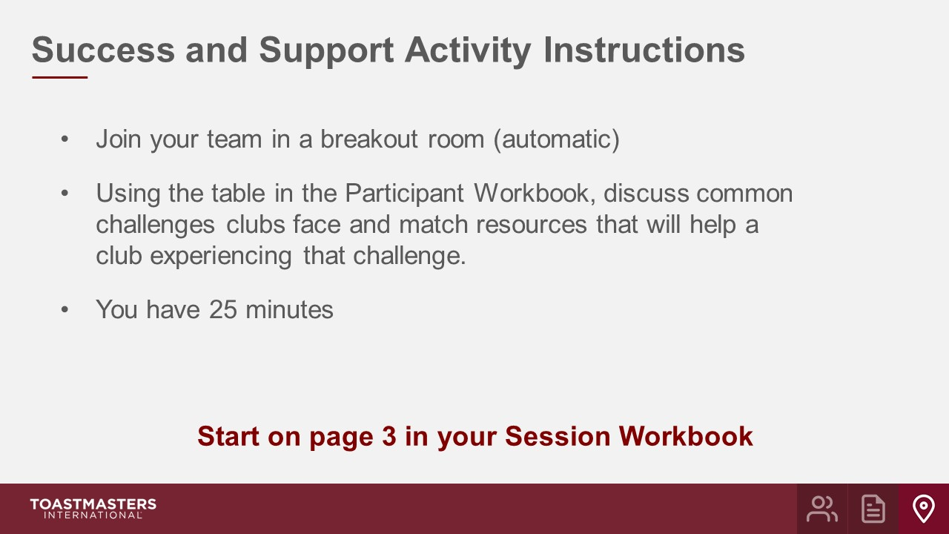
PRESENT
- We will send a two-minute warning before the end of each scenario.
- I will be available to answer questions or provide assistance.
OPEN Breakout Rooms for activity (ideally 3-4 Area Directors per room).
MONITOR requests for assistance from Breakout Rooms.
VISIT Breakout Rooms to offer assistance and guidance, as needed.
SEND Broadcast after 10 minutes has elapsed: You have 15 more minutes.
SEND Broadcast after 20 minutes has elapsed: You have 5 more minutes.
SEND Broadcast after 23 minutes has elapsed: In approximately 2 minutes, you will be asked to return to the main session room.
CLOSE Breakout Rooms after 25 minutes.
SHOW the Whole Room Discussion slide.
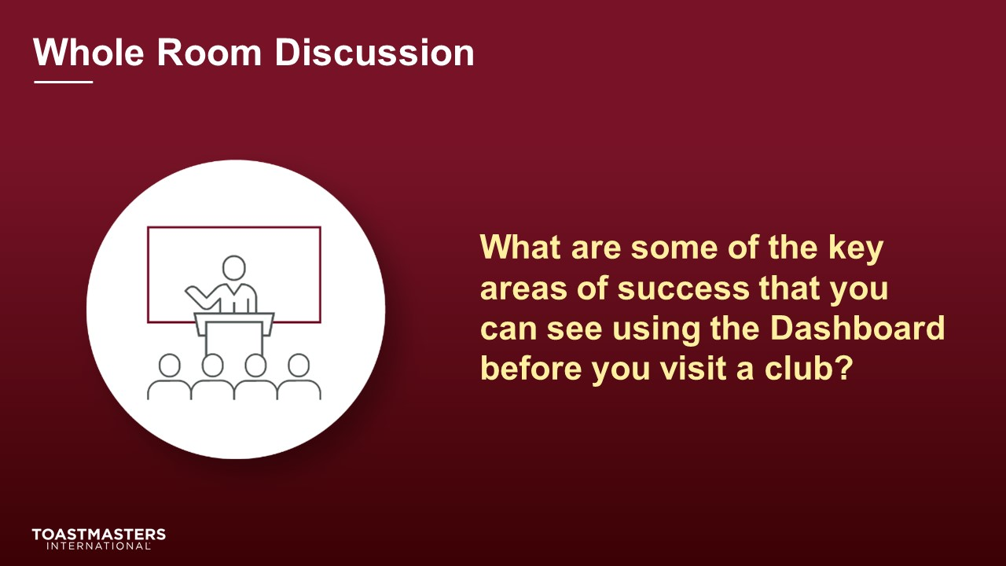
DISCUSS responses for up to two minutes.
SHOW the Whole Room Discussion slide.
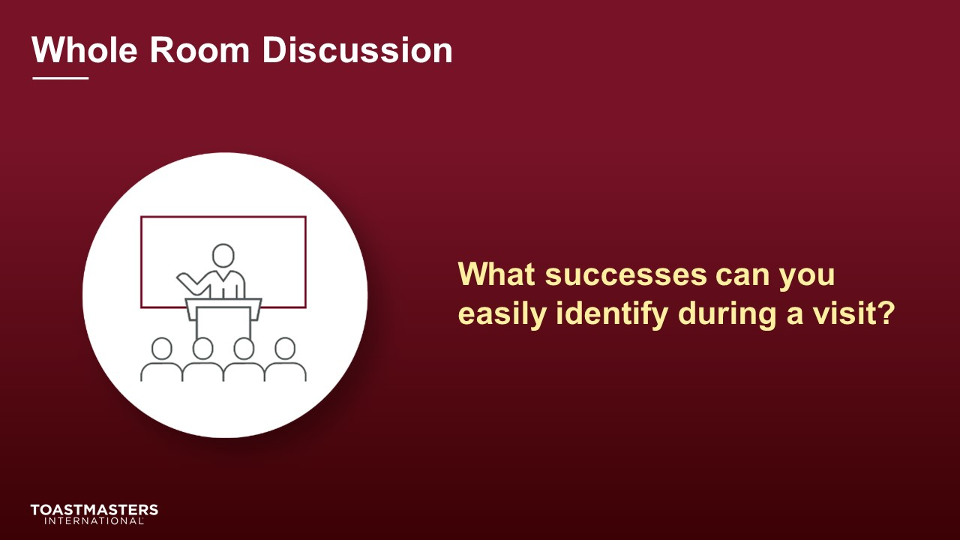
DISCUSS responses for up to two minutes.
SHOW the Whole Room Discussion slide.
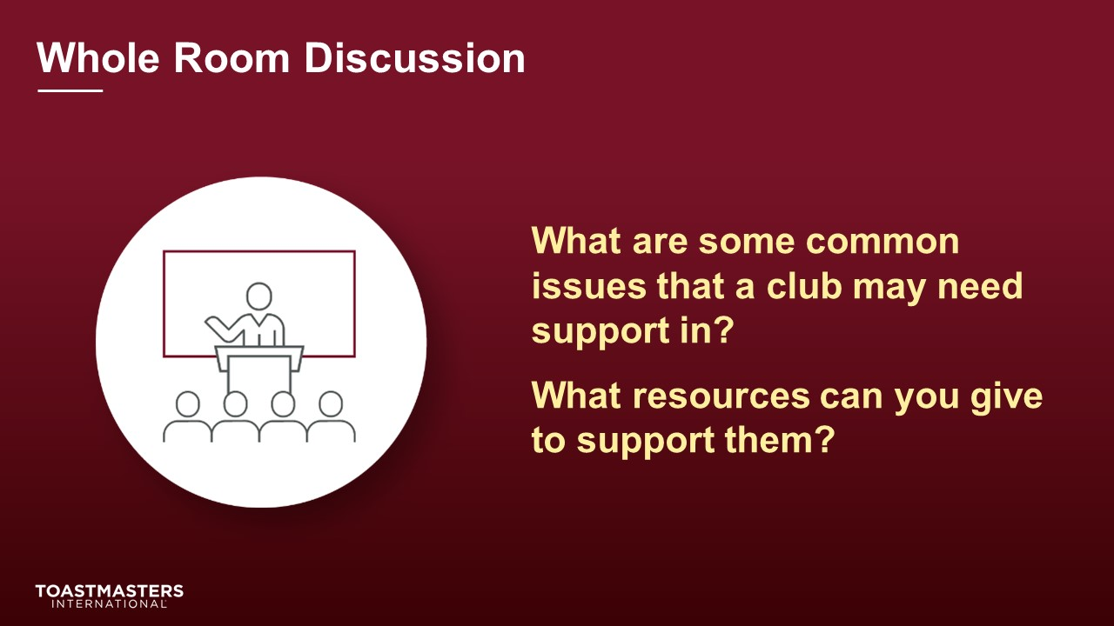
DISCUSS responses for up to two minutes.
SHOW the Whole Room Discussion slide.
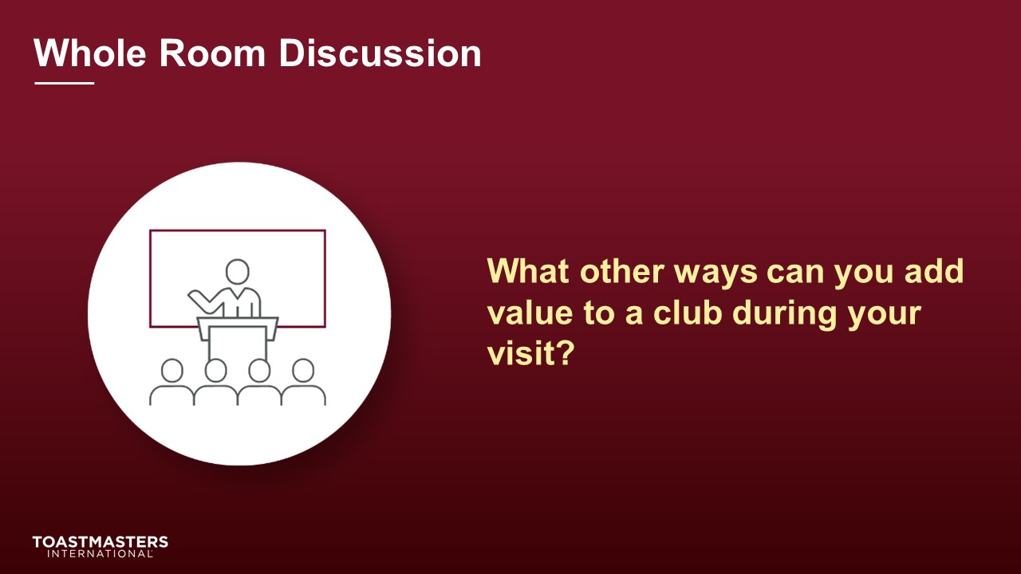
DISCUSS responses for up to two minutes.
DISCUSS responses for up to two minutes.
SHOW the Review slide.
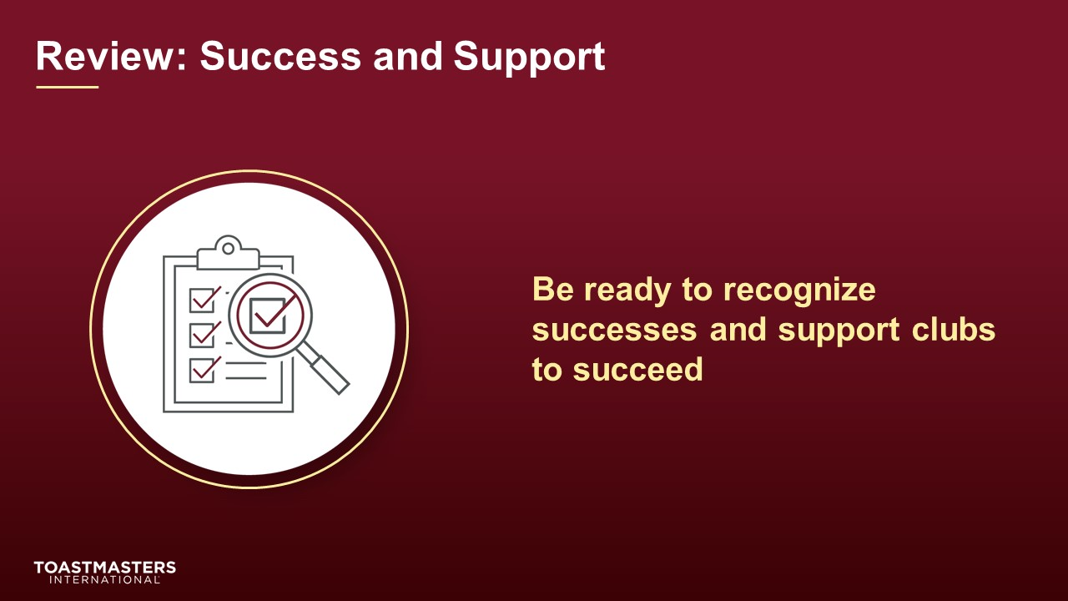

Conclusion
(10 minutes)
SHOW the Conclusion slide.
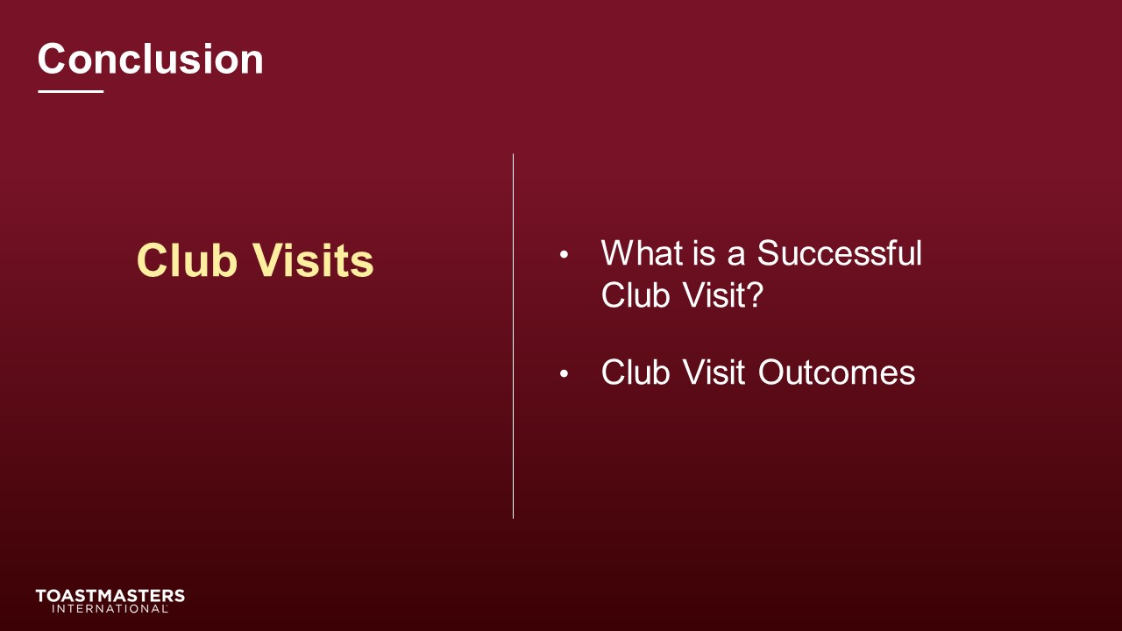
PRESENT
- There are resources in your Session Workbook on page 4 and a reflection activity on page five for you to complete on your own.
SHOW the Chat slide.

MONITOR chat responses.
DISCUSS responses for up to two minutes.
note to facilitator
The following two slides should be edited to fit your requirements.
SHOW the Session Assessment slide.
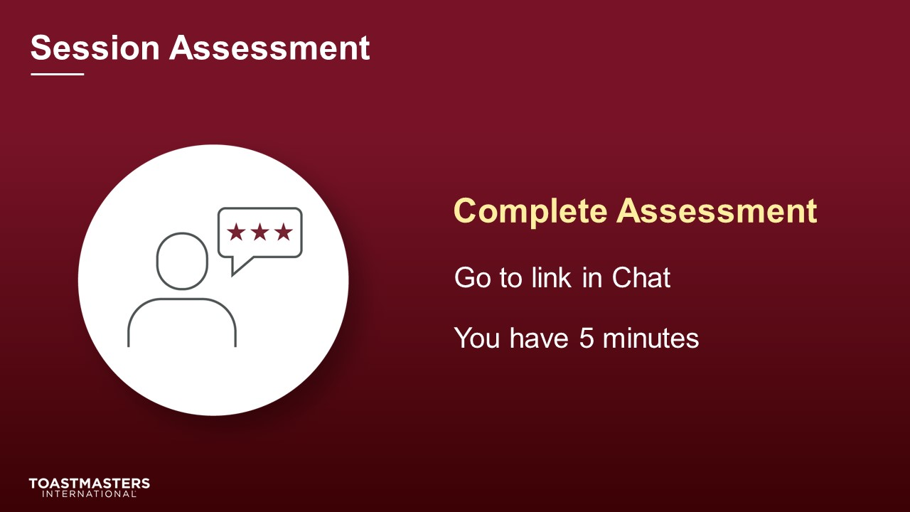
SEND chat message to everyone: [insert link to assessment]
SHOW the What is Next slide.
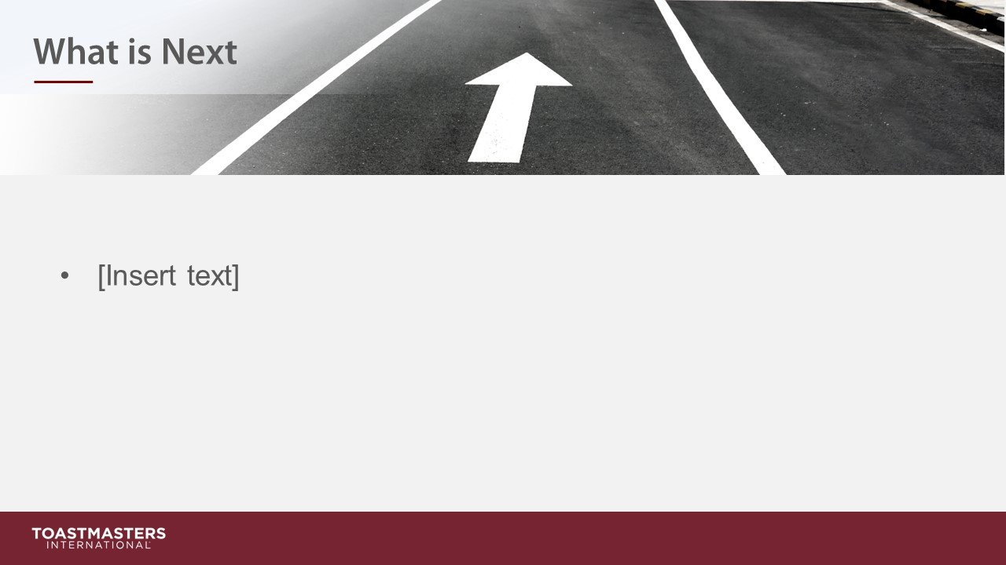
PRESENT
- [insert your talking points here]

